  GIS Forum  Croatian GIS Association |   Hydrographic Institute  of the Republic of Croatia |   Institute of Oceanography and Fisheries | 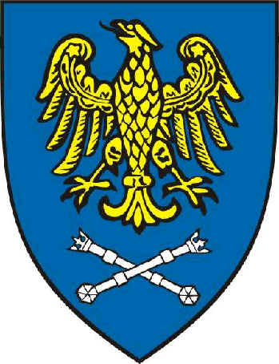  University of Silesia

Geographic Information Systems Conference and Exhibition
Croatian GIS Association
International Geographic Information Systems
“GIS ODYSSEY 2010” , 3rd to 7th of September 2010
Conference & Exhibition
Croatia: Brijuni, Istra & Pula
Conference Hall & Accommodation
Hotel “Neptun-Istra-Karmen”, Brijuni

THIRD CALL

PATRON

State Geodetic Administration, Croatia
Organisers
HIZ - GIS Forum, Croatia
Hydrographic Institute of the Republic of Croatia
Institute of Oceanography and Fisheries, Croatia
University of Silesia, Poland – Faculty of Computer Science and Materials Science,
Faculty of Earth Sciences
SILGIS Association, Poland
Cardinal Stefan Wyszyński University, Warsaw, Poland

Organising Committee

Chairman: Davorin Kereković, GIS Forum, Zagreb, Croatia
Dr. Zvonko Gržetić, Hydrographic Institute of the Republic of Croatia, Split, Croatia
Prof. dr. Vlado Dadić, Institute of Oceanography and Fisheries, Split, Croatia
Dr. Małgorzata Gajos, University of Silesia, Sosnowiec, Poland
Dr. Urszula Myga-Piątek, University of Silesia, Sosnowiec, Poland
Maria Styblińska, University of Silesia, Sosnowiec, Poland

Main conference topics

Geoinformatics
- Geodesy and cartography
- Space and informatics’ law & ethics
- Structure and function of the geographical environment

Cultural and natural heritage management
- DIGITAL HERITAGE
- Post – war and post – disaster reconstruction projects
- Municipal space management

Agriculture and forestry
- Water, hydrography and sea management
- Emergency management
- Earth resources management
- European Corridor baltic Sea - Adriatic Sea
- Globalisation, development and transition process

Informatics & Communication
- Other

2

Contact persons:

Davorin Kereković,Croatian GIS Forum secretary
Address: 10 000 Zagreb, Prisavlje 12, Croatia
E-mail: davorin.kerekovic@zg.t-com.hr
tel/fax: 00 385 1 619 69 03, GSM: 00 385 98 384 177

Dr. Małgorzata Gajos Dr. Urszula Myga-Piątek
University of Silesia University of Silesia
Faculty of Computer Science and Materials Science Faculty of Earth Sciences
Będzińska 39, 41-200 Sosnowiec, Będzińska 60, 41-200 Sosnowiec
Poland Poland
E-mail: gajos@us.edu.pl E-mail: ump@wnoz.us.edu.pl

Maria Styblińska
University of Silesia
Faculty of Computer Science and Materials Science
Będzińska 39, 41-200 Sosnowiec,
Poland
E-mail: maria.styblinska@us.edu.pl

Honorary Committee:

dr.sc. Zvonko Gržetić, Hydrographic Institute of the Republic of Croatia, Croatia
Prof. dr. Bonawentura Maciej Pawlicki, Cracow University of Technology, Poland
Prof. dr. Ivona Marasović, Institute of Oceanography and Fisheries, Split, Croatia
Prof. dr. Wiesław Banyś, University of Silesia, Poland
Prof. dr. Stanislav Frangeš, University of Zagreb, Faculty of Geodesy, Croatia
Prof. dr. Zygmunt Wróbel, University of Silesia, Poland
dr.sc Vlatko Maček, University of Zagreb, FOI, Croatia
Krzysztof Mączewski, BGWM, Warsaw, Poland

Scientific Committee:

Prof. dr. Stanislaw Ostaficzuk, Minerals and Energy Economy Research Institute of PAS, Poland
Prof. dr. Andrzej Szewc, University of Silesia, Sosnowiec, Poland
Prof. dr. Grażyna Szpor, Cardinal Stefan Wyszyński University, Warsaw, Poland
Prof. dr. Wojciech Wilkowski, Warsaw University of Technology, Poland
Prof. dr. Elżbieta Bielecka, Military University of Technology, Warsaw, Poland
Prof.dr. Katarzyna Sobolewska - Mikulska, Warsaw University of Technology, Poland

Prof. dr. Anka Mašek, University of Osijek, Faculty of Economics, Osijek, Croatia
dr. sc. Danko Markovinović, University of Zagreb, Faculty of Geodesy, Croatia
dr.sc. Andrzej Michalski, Silesian University of Technology, Katowice, Poland
dr.sc. Renata Pernar, University of Zagreb, Faculty of Forestry, Zagreb, Croatia
dr.sc. Hrvoje Stančić, University of Zagreb, Croatia

Davorin Kereković,Croatian GIS Forum secretary, Address: 10 000 Zagreb, Prisavlje 12, Croatia
E-mail: davorin.kerekovic@zg.t-com.hr
tel/fax: 00 385 1 619 69 03,GSM: 00 385 98 384 177

